**Regularization and Bias/Variance**

**Note:** [The regularization term below and through out the video should be and **NOT**]

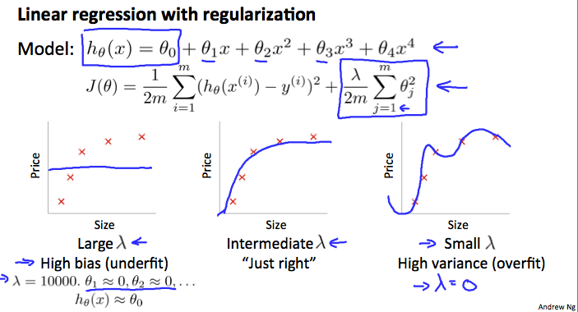

In the figure above, we see that as λ increases, our fit becomes more rigid. On the other hand, as λ approaches 0, we tend to over overfit the data. So how do we choose our parameter λ to get it 'just right' ? In order to choose the model and the regularization term λ, we need to:

1. Create a list of lambdas (i.e. λ∈{0,0.01,0.02,0.04,0.08,0.16,0.32,0.64,1.28,2.56,5.12,10.24});
2. Create a set of models with different degrees or any other variants.
3. Iterate through the λs and for each λ go through all the models to learn some Θ.
4. Compute the cross validation error using the learned Θ (computed with λ) on the JCV(Θ) **without** regularization or λ = 0.
5. Select the best combo that produces the lowest error on the cross validation set.
6. Using the best combo Θ and λ, apply it on Jtest(Θ) to see if it has a good generalization of the problem.